Immersive Python Workshop (Winter 2026): Testing your local Python installation

Welcome! If you have downloaded and installed Python but have never used it before, or you have used Python but not with VSCode, you will want to follow these short steps. Internet connection is required for this short test, which should take no more than about 5 minutes.

Step 1: Download the Python file
- Go to this UT Box link and download the file: https://utexas.box.com/s/l2pnjbuq6mmqmq8pa7fil8yjg8sef63l

Step 2: Install an external Python module
- As part of this test, we will be testing whether your Python is able to correctly detect a module that is not part of the default Python install: pandas.
  - MacOS users:
    - Open the Terminal and enter this command:
    - python3 -m pip install pandas
  - Windows users:
    - Open the Terminal (Windows Powershell) or Command Prompt and enter this command:
    - python -m pip install pandas

- A lot of lines of code will appear quickly. If the installation is complete, you will see a final message indicating as much. If you see an error message, or the command fails, please reach out, as this likely indicates an issue with your Python installation.

Step 3: Get set up in VSCode
- If you have never run VSCode before, you will need to click through some welcome messages, etc. If it asks you any questions, the default settings should be fine…
- VSCode cannot run Python files by default - you need an extension. On the left sidebar, you should see this icon for the Extensions:
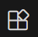
- If you don’t see if for some reason, click on View -> Extensions

- Search ‘Python’; many options will show up, but it should be the first or second one that is just called ‘Python’ (nothing after it). If you click on it, you should see this:
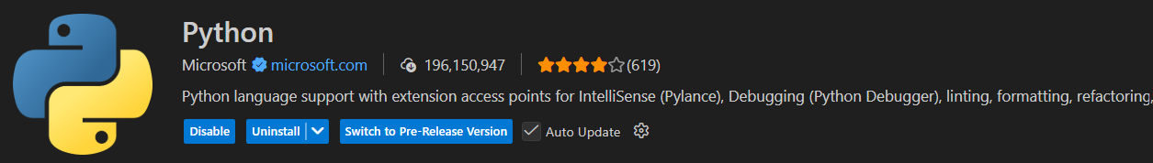

(although you will not see the same blue boxes unless you already have the extension installed)

- It may require you to also install some accessory extensions - this is fine as long as you install the official Python extension from Microsoft - make sure there is a blue checkmark next to it and about 200,000,000 downloads.

Step 4: Run the script
- Locate the downloaded file; it should be called python-installation-test.py
- The only thing that you need to do to run the script is to put your name in between the quotation marks in line 2:

user = " " # User should change this to their name

- So it should look like this:
user = "Alex Marden" # User should change this to their name

- In order to run the script, look in the top right of the VSCode window:

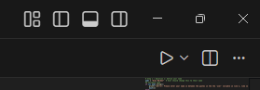

- Click the play (triangle) button to run the script. The script is designed to show you different messages based on whether or not the step was successful, but it will complete either way and fill out information in a private Google Form so that we can log a record of where you encountered problems.
  - FAQ: if you do not see the triangle button, it means you did not install the extension for Python; if you just installed it, you likely need to exit out and reopen the program.

